**Proceedings of the ASME 2020**

**International Mechanical Engineering Congress and Exposition**

**IMECE2020**

**November 15-19, 2020, Portland, OR, USA**

IMECE2020-21865

In-Plane Vibration Mode Shapes for Rotating Disks – Exact Solution

|  |
| --- |
| Ehsan Sarfaraz, Hamid R. Hamidzadeh  Department of Mechanical and Manufacturing Engineering  Tennessee State University  Nashville, TN 37209  Email: [ehssar60@gmail.com](mailto:esarfara@my.tnstate.edu), [hhamidzadeh@tnstate.edu](mailto:hhamidzadeh@tnstate.edu) |

|  |  |  |
| --- | --- | --- |
|  |  |  |

**Abstract**

An analytical method is developed for the determination of modal vibration characteristics of high speed rotating annular disks. A systematic approach based on established solutions for the linear in-plane free vibrations of the disks which satisfy the displacement and stresses compatibilities is developed. The disk is considered to be a homogeneous, thin and elastic isotropic, and it is rotating at constant angular speed. The developed analytical solution was obtained by implementing the two-dimensional plane stress theory. In this research, fixed-free and free-free boundary conditions for the annular disks are considered, and natural frequencies, as well as mode shapes of the rotating disks, are computed. The mode shapes are represented by eight functions in polar coordinates. The dimensionless natural frequency parameters are depicted for free vibration of the system for a range of dimensionless rotation speed and radius ratios. Also, the results provide several non-dimensional critical speeds.

**Nomenclature**

Elastic rotation factor

Inner radius of the disk

Outer radius of the disk

Modulus of elasticity

Number of nodal circles

Number of nodal diameters

Natural frequency experienced on rotating coordinates

Natural frequency experienced on fix coordinates

Radial coordinate

Dimensionless radial coordinate

Rotating polar coordinate fixed to the disk

Time

Radial displacement

Tangential displacement

Non-dimensional radial displacement

Non-dimensional tangential displacement

Shear strain

Radial wave velocity

Tangential wave velocity

Radial stress

Non-dimensional radial stress

Shear stress

Non-dimensional shear stress

Radius ratio

Shear modulus

Density of the medium

Poisson’s ratio

Volumetric strain

Angular speed of rotation

Non-dimensional natural frequency in a fixed coordinate system

Non-dimensional natural frequency in a rotating coordinate system

Dimensionless rotational speed

Dimensionless natural frequency

Laplacian operator

Introduction

In view of vast potential applications of the flexible thin rotating disks, the knowledge of their vibration characteristics has been received extensive attention in the past few years. Rotating disks are the principal components in engineering systems such as flywheels, torsional disk dampers, turbine blades, circular saws, hard-disk drives for computers, optical memory disks (CD and DVD) and etc. With the advent of these components, demand to increase their efficiency and to reduce access times for reaching the operating speed has led to progressive increases in the rotational speed of these components. Therefore, vibration analysis for rotating disks has gain higher attention in recent research works. While the main emphasis has always been given to linear and non-linear transverse vibration of the rotating disk. Nevertheless, during recent years it has been realized that in-plane vibration can also play a significant role in the design of rotating disks. Much of the recent interest is due to the important significance for vibration and noise reductions caused by in-plane vibrations in varieties of the practical applications.

Analysis of rotating disks has been studied in past several decades and many research efforts are made for the in-plane vibration analysis of rotating annular disks, such as the works by Chen and Jhu, Hamidzadeh and Sarfaraz, Bashmal et al, and Lyu et al. The in-plane vibration of circular disks was first investigated by Love [1] who formulated the equations of motion for a thin solid circular disk with a free outer edge together with the general solution. Burdess et al. [2] presented a generalized formulation to consider asymmetric in-plane vibrations, while the effect of rotational speed on forward and backward traveling waves of a two nodal diameter mode was discussed. In their work, the equations of motion of a thin rotating disk were derived and solved for the general case by expressing the disk displacement in terms of a scalar and vector potential. Then, properties of the free and forced solutions were determined and results relating to the stability and resonant behavior of the disk were derived.

Before Chen and Jhu [3], in most of those works, the disk was assumed to be full. Chen and Jhu [3] determined the free in-plane vibration of a thin spinning annular disk and investigated the effects of clamping ratio on the natural frequencies and stability of disks. They extended the analysis to study the divergence instability of spinning annular disks clamped at the inner edge and free at the outer boundary. The effect of radius ratio on the natural frequencies and critical speeds of the disk was also investigated. They also [4] derived the analytical solution for the in-plane stress and displacement distributions in a spinning annular disk under stationary edge loads. Hamidzadeh [5] presented computational results for fixed-free dimensionless rotating disk for the speed ranging from 0 to 1.5 and computed dimensionless natural frequencies for several modes. Farag and Pan [6] evaluated the frequency parameters and the mode shapes of in-plane vibration of solid disks clamped at the outer edge using assumed deflection modes in terms of trigonometric and Bessel functions. Bashmal et al. [7,8] have studied a generalized formulation for in-plane vibration analyses of circular annular disks under different combinations of boundary conditions at the inner and outer edges.

In addition to the homogeneous material cases, with the development of material science and engineering, in-plane vibration of annular disks made of various materials is also investigated to obtain a deep understanding on dynamic characteristics of this vibration form. Sarfaraz and Hamidzadeh [9-11] studied the effect of material hysteretic damping of the disk on the natural frequencies of a fixed-free rotating disk by considering constant complex elastic moduli. In their work, the prediction of in-plane natural frequencies and depict their modal loss factors of in-plane vibration accurately were obtained. They [11-13] also developed a governing equation of motion to obtain the displacements and stresses distributions for the discontinuous compound disk. The analysis was conducted to evaluate the effect of added segment with higher mass, at the inside or outside edge of the disk, on the natural frequencies and critical speeds. Bagheri and Jahangiri [14] explored the in-plane free vibration analysis of the functionally graded rotating disks with variable thickness is presented utilizing DQM.

Recently, Lyu et al. [15] obtained a solution for the in-plane vibration analysis of rotating circular panels with general edge restraints by solving the governing equations and boundary conditions, simultaneously. Two coupled in-plane displacement fields are constructed as Fourier series with smoothed supplementary polynomials to remove the relevant differential discontinuities associated with the original radial component at inner and/or outer edges of disk. They [16] also proposed an efficient solution for the in-plane vibration analysis of annular panel with arbitrary distribution of internal point constraints that Energy principle is employed for the in-plane vibration description of the annular panel system to predict in-plane modal frequencies and mode shapes.

The presented results include variations of the geometrical shape of the disk by considering radial and tangential displacement of all points within the disk for different mode shapes. In this research, the main objectives are to provide the analytical solution for the determination of the natural frequencies and present their mode shapes for stresses and displacements of the rotating annular disk. It should be noted that the disk is rotating at a constant angular speed, and no external forces are acting on it. Furthermore, the analysis is conducted for a steady-state rotational disk for the wide range of rotating speed.

**Governing equations**

A modal of a two-dimensional homogeneous, elastic and isotropic disk rotating about its axis is shown in Figure 1. Terms are radial and tangential displacement of a point in rotating polar coordinates. The material of the disk is assumed to be homogeneous, elastic and isotropic. The disk is rotating at a constant angular speed therefore angular acceleration is zero. Since the disk is assumed thin, the two-dimensional theory of elasticity is applied to derive the stress and strain in polar coordinates. As it was presented by Hamidzadeh [5], equations of motion in terms of volumetric strains and elastic rotation for the freely rotating annular disk are given by:

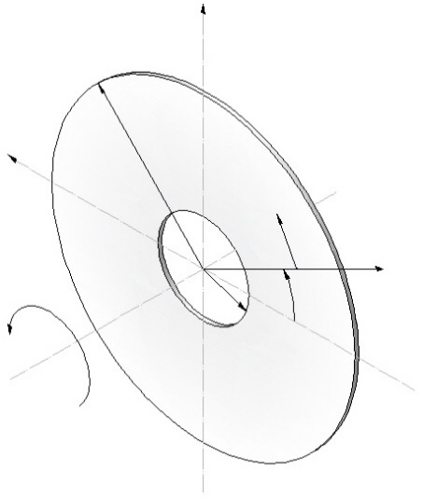

**y**

**b**

**v**

**o**

**u**

**a**

**x**

**z**

Figure 1.Rotating annular disk in polar coordinate

(1)

(2)

and are radial and tangential displacements. Volumetric strain as sum of the radial and tangential strains and as the elastic rotation, these are presented in terms of displacements by the following relations:

(3)

(4)

Defining , and shear modulus

(5)

(6)

(7)

Introducing radial and shear wave velocities as

(8)

(9)

The solutions to the wave operators and were presented by Hamidzadeh [5].

**Modal displacements and stresses**

The radial and tangential displacement and modal radial and shear stresses can be written by the following equations:

(10)

(11)

(12)

(13)

By introducing the non-dimensionalized variables:

, , , (14)

, , , (15)

then modal displacements and stresses at any radius for annular disk according to Hamidzadeh [5] will be presented in the following equation.

(16)

Elements of are in terms of material properties and Bessel functions of First and Second kinds. These elements are presented in the above-mentioned paper [5].

**MODAL ANALYSIS**

To determine the modal information, the boundary conditions must be satisfied. Expressions for the elements of are provided in reference [5]. For the free-free boundary conditions, it is required that the modal radial and shear stresses at both inner and outer radius must be zero. By implementing the boundary conditions on the equation (16) and combining them, displacements and stresses at the boundaries are related in the following form:

(17)

Assuming in the following form

(18)

Based on equations (17) and (18), it can be derived that the inner boundary stresses will be given by

(19)

In order to obtain a nonzero solution for the stresses, the determinant of the matrix in equation (19) must be zero. This results in the frequency equation for the free-free system:

(20)

In the similar way, for the fixed-free boundary condition, it is required that the modal radial and tangential displacements at the inner side of the disk and the modal radial and shear stresses at the outer radius must be zero. Therefore, displacements and stresses at the boundaries are related in the following form:

(21)

Similarly, the frequency equation for the fixed-free system can be written as:

(22)

The frequency equation is a function of circumferential wave number and dimensionless parameters of and. For given values of and there are infinite real values for that satisfy this equation. Dimensionless frequencies in the rotating coordinate system are given by the absolute values of :

(23)

**MODE SHAPES**

Modal vibration characteristics are extremely important in vibration analysis. The concept of mode of vibration refers to the particular natural frequency and its corresponding mode shape. Mode shapes indicate the relative position of a system at any given instant of time for a given natural frequency. Mode shapes are important in that they give an idea of how the system is going to vibrate physically. Mode shapes for the in-plane free vibration of a rotating disk can be identified by the number of circular nodes () and diametrical nodes () and is composed of an infinite number of combinations of nodal circles and nodal diameters. A disk vibrating at number of nodal circles will have zero displacement occurring perpendicular to the disk plane during vibration. A disk vibrating with number of nodal diameters will have no deflection occurring during vibration.

The modes of vibration of a disk are classified as Breathing mode when and, Breathing mode with thickness modes when and, the thickness mode indicates the number of nodal circles, and Lobar modes when and. Thickness modes are best introduced by using a mathematical explanation. Vibration of a disk is composed mathematically of an infinite number of circumferential wave numbers (), i.e. the breathing, torsional and radial modes. Furthermore, for each circumferential number there are an infinite number of modes related to the infinite number of values, where one of displacement functions vanishes. This is duo to the nature of the involved Bessel functions. Therefore, for the vibration of the thin rotating disk, there are infinite by infinite sets of vibration modes and for each mode, there are its natural frequency and its respective mode shape. However, the lower modes () have been found to be the dominant modes of vibration. Thus, whenever these types of structures are excited at a high natural frequency, a number of nodal circles can occur. These nodal circles describe the thickness modes.

For mode shapes, if the direction of oscillating wave is the same as that of rotation of the disk () in rotating coordinates, it is defined as forward wave in rotating coordinates. If the direction of oscillating wave is opposite to that of rotation of the disk () in rotating coordinates, it is defined as backward wave in rotating coordinates. For mode shapes, if the direction of oscillating wave is the same as that of rotation of the disk () in fixed coordinates, it is defined as forward wave in fixed coordinates. If the direction of oscillating wave is opposite to that of rotation of the disk ) in fixed coordinates, it is defined as backward wave in fixed coordinates. So, the relation between natural frequency in fixed coordinates  and rotating coordinates ) and the relation between dimensionless natural frequencies in fixed and rotating coordinate system can be presented by the following equations:

(24)

(25)

(26)

As a result, for the mode shapes, whenever nodal circles exist, there will be radial or torsional vibration or both. When nodal diameters exist, the disk will vibrate in a set oscillation pattern. Thus, when a combination of nodal circles and nodal diameters exists, the disk will experience radial and torsional vibration and vibration at set oscillating pattern. All the vibration and displacement occur in the plane of rotation of the disk. For the Lobar mode, there is no deflection of the disk, only oscillation of the disk is observed that means rotating disk is subjected only to in-plane vibration. Figures 2 and 4 show the variation of dimensionless natural frequencies that is experienced in fixed coordinates for different modes versus dimensionless speed of a disk with various radius ratios (() Figure 2 and () Figure 4) for boundary condition of free at the inner edge and free at the outer edge. The computed results were extended covering for dimensionless rotational speed well beyond the speeds previously considered in established publications. Presented results are for both backward and forward modes associated with different numbers of nodal circles) and nodal diameters. The label refers to the backward wave and the label refers to the forward wave. Furthermore, Figures 3 and 5 demonstrates the dimensionless natural frequency experienced in fixed coordinates for different modes versus dimensionless rotating speed of disk, with various radius ratios (() Figure 3 and () Figure 5), fixed at the inner edge and free at the outer edge of the disk (fixed-free) for Poisson’s Ratio of 0.3.

Based on these results, it can be concluded that by increasing the radius ratio and wave numbers of and, natural frequencies increase. Furthermore, it can be observed the effect of boundary conditions on natural frequencies, for example, in a specific mode of a fixed-free rotating disk, fundamental critical speed is higher respect to a free-free rotating disk, since the inner side of the disk is clamped thus, the disk is more stable compare to the free-free disk and natural frequencies respectively are higher.

**(5,0)**

**(4,0)**

**Dimensionless natural frequency,**

**(2,0)**

**(3,0)**

**Dimensionless natural frequency,**

**(1,0)**

**(0,0)**

**Dimensionless rotational speed,**

**(3,1)f**

**(5,1)f**

**(4,1)f**

**Dimensionless natural frequency,**

**(2,1)b**

**Dimensionless natural frequency,**

**(5,1)b**

**(2,1)f**

**(4,1)b**

**(1,1)f**

**(3,1)b**

**(1,1)b**

**(0,1)b**

**(0,1)f**

**Dimensionless rotational speed,**

**(2,2)f**

**(3,2)f**

**(4,2)f**

**(5,2)f**

**Dimensionless natural frequency,**

**(5,2)b**

**Dimensionless natural frequency,**

**(1,2)f**

**(1,2)b**

**(2,2)b**

**(0,2)f**

**(3,2)b**

**(4,2)b**

**Dimensionless rotational speed,**

**(0,2)b**

**(5,3)f**

**(4,3)f**

**(2,3)f**

**(1,3)f**

**(3,3)f**

**(5,3)b**

**(4,3)b**

**(0,3)f**

**Dimensionless natural frequency,**

**Dimensionless natural frequency,**

**(2,3)b**

**(3,3)b**

**(1,3)b**

**(0,3)b**

**Dimensionless rotational speed,**

**(4,4)f**

**(5,4)f**

**(2,4)f**

**(0,4)f**

**(1,4)f**

**(3,4)f**

**(5,4)b**

**Dimensionless natural frequency,**

**Dimensionless natural frequency,**

**(1,4)b**

**(3,4)b**

**(4,4)b**

**(2,4)b**

**(0,4)b**

Figure 2. Variation of dimensionless natural frequency versus dimensionless speed for different modes of a free-free disk with a radius ratio and

**Dimensionless rotational speed,**

**(4,0)**

**(5,0)**

**(3,0)**

**(2,0)**

**(1,0)**

**Dimensionless rotational speed,**

**(5,1)f**

**(4,1)f**

**(3,1)f**

**(2,1)f**

**(5,1)b**

**(4,1)b**

**(1,1)b**

**(0,1)f**

**(0,1)b**

**(3,1)b**

**(2,1)b**

**(1,1)f**

**Dimensionless rotational speed,**

**(4,2)f**

**(5,2)f**

**(2,2)f**

**(3,2)f**

**(4,2)b**

**(1,2)f**

**(5,2)b**

**(1,2)b**

**(2,2)b**

**(3,2)b**

**(0,2)f**

**(0,2)b**

**Dimensionless rotational speed,**

**(5,3)f**

**(4,3)f**

**(3,3)f**

**(2,3)f**

**(1,3)f**

**(5,3)b**

**(0,3)f**

**(4,3)b**

**(3,3)b**

**(2,3)b**

**(1,3)b**

**(0,3)b**

**Dimensionless rotational speed,**

**(5,4)f**

**(3,4)f**

**(4,4)f**

**(2,4)f**

**(0,4)b**

**(0,4)f**

**(1,4)f**

**(4,4)b**

**(5,4)b**

**(1,4)b**

**(2,4)b**

**(3,4)b**

**Dimensionless rotational speed,**

Figure 3. Variation of dimensionless natural frequency versus dimensionless speed for different modes of a fixed-free disk with a radius ratio and

**(4,0)**

**(3,0)**

**Dimensionless natural frequency,**

**(1,0)**

**(2,0)**

**Dimensionless natural frequency,**

**(0,0)**

**Dimensionless rotational speed,**

**(4,1)b**

**(5,1)b**

**(1,1)f**

**(2,1)f**

**(3,1)f**

**Dimensionless natural frequency,**

**(3,1)b**

**(2,1)b**

**Dimensionless natural frequency,**

**(0,1)f**

**(1,1)b**

**(0,1)b**

**Dimensionless rotational speed,**

**(4,2)f**

**(5,2)b**

**(2,2)f**

**(3,2)f**

**(4,2)b**

**(1,2)f**

**Dimensionless natural frequency,**

**Dimensionless natural frequency,**

**(1,2)b**

**(2,2)b**

**(3,2)b**

**(0,2)f**

**(0,2)b**

**Dimensionless rotational speed,**

**(1,3)f**

**(2,3)f**

**(3,3)f**

**(4,3)f**

**Dimensionless natural frequency,**

**Dimensionless natural frequency,**

**(0,3)f**

**(3,3)b**

**(4,3)b**

**(2,3)b**

**(1,3)b**

**(0,3)b**

**Dimensionless rotational speed,**

**(4,4)f**

**(2,4)f**

**(3,4)f**

**(1,4)f**

**(0,4)f**

**Dimensionless natural frequency,**

**Dimensionless natural frequency,**

**(0,4)b**

**(1,4)b**

**(2,4)b**

**(3,4)b**

**(4,4)b**

Figure 4. Variation of dimensionless natural frequency versus dimensionless speed for different modes of a free-free disk with a radius ratio and

**Dimensionless rotational speed,**

**(4,0)**

**(3,0)**

**(1,0)**

**(2,0)**

**(0,0)**

**Dimensionless rotational speed,**

**(3,1)f**

**(4,1)f**

**(5,1)b**

**(3,1)b**

**(4,1)b**

**(2,1)b**

**(1,1)f**

**(2,1)f**

**(1,1)b**

**(0,1)b**

**(0,1)f**

**Dimensionless rotational speed,**

**(4,2)f**

**(1,2)f**

**(2,2)f**

**(5,2)b**

**(3,2)f**

**(3,2)b**

**(4,2)b**

**(0,2)b**

**(1,2)b**

**(0,2)f**

**(2,2)b**

**Dimensionless rotational speed,**

**(1,3)f**

**(2,3)f**

**(3,3)f**

**(0,3)b**

**(3,3)b**

**(4,3)b**

**(0,3)f**

**(1,3)b**

**(2,3)b**

**Dimensionless rotational speed,**

**(1,4)f**

**(2,4)f**

**(3,4)f**

**(0,4)f**

**(4,4)b**

**(0,4)b**

**(2,4)b**

**(3,4)b**

**(1,4)b**

**Dimensionless rotational speed,**

Figure 5. Variation of dimensionless natural frequency versus dimensionless speed for different modes of a fixed-free disk with a radius ratio and

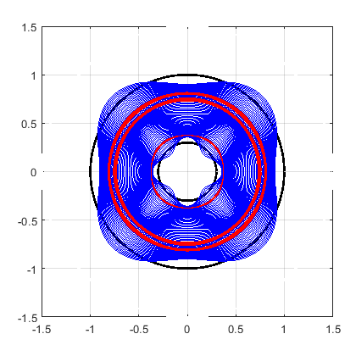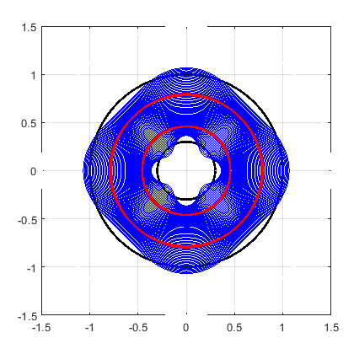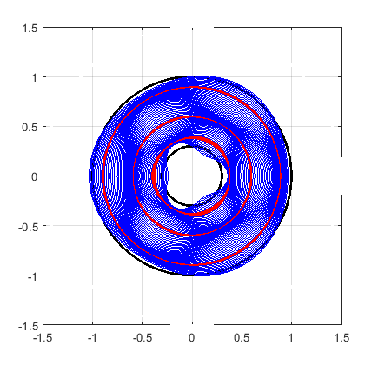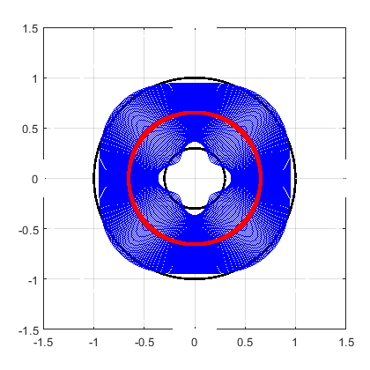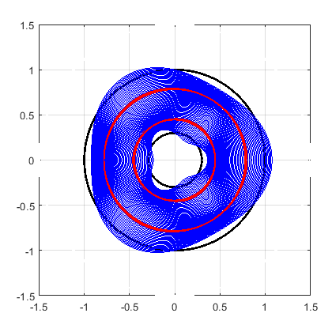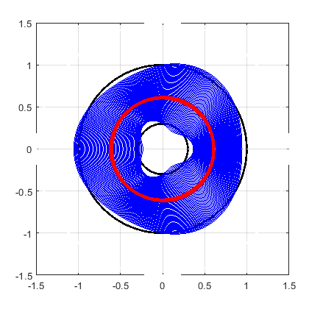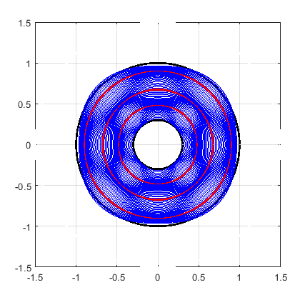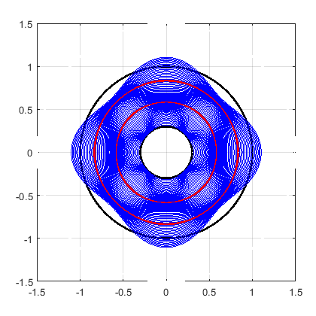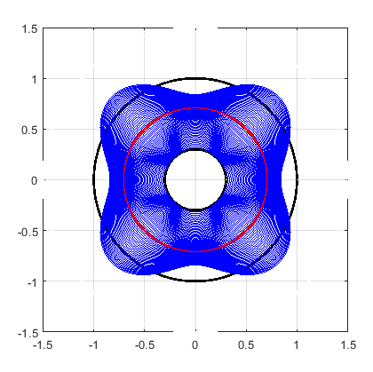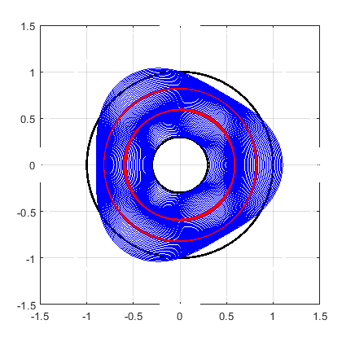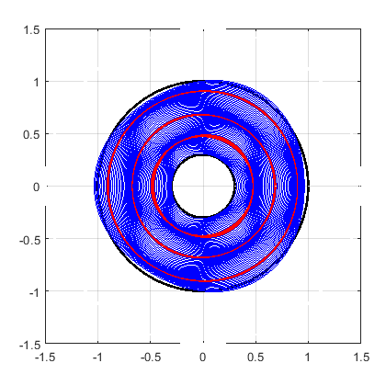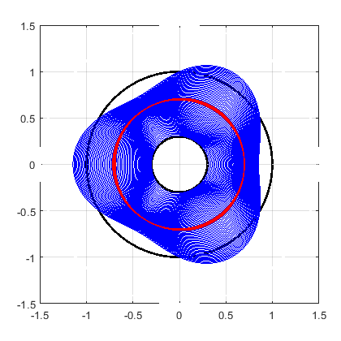Figure 6. Circumferential mode shapes of fixed-free and free-free annular rotating disks ()

**Free-Free (3,4)**

**Free-Free (2,4)**

**Free-Free (1,4)**

**Free-Free (3,3)**

**Free-Free (2,3)**

0

**Free-Free (1,3)**

**Fixed-Free (2,4)**

**Fixed-Free (3,4)**

**Fixed-Free (3,3)**

**Fixed-Free (1,4)**

**Fixed-Free (2,3)**

0

**Fixed-Free (1,3)**

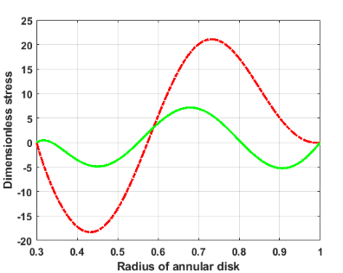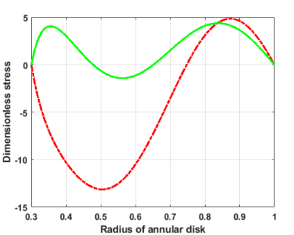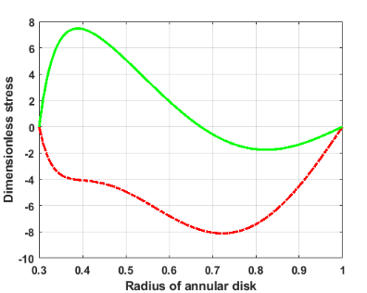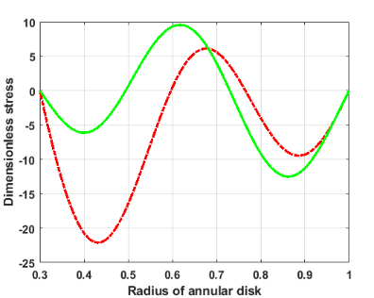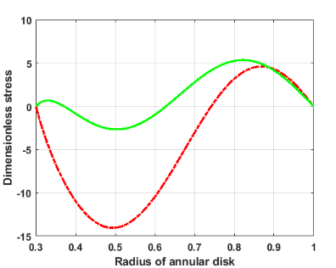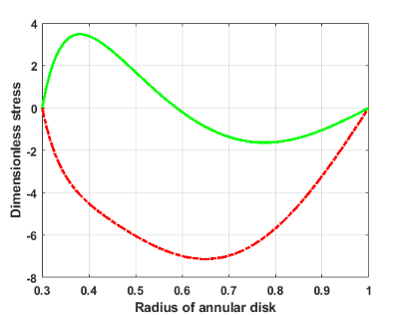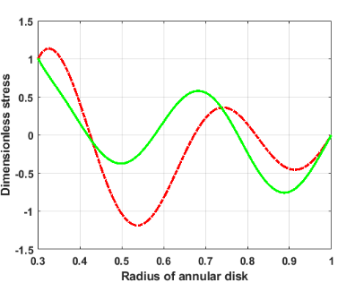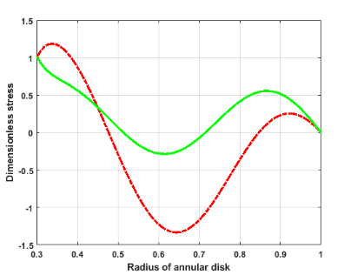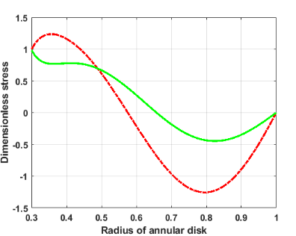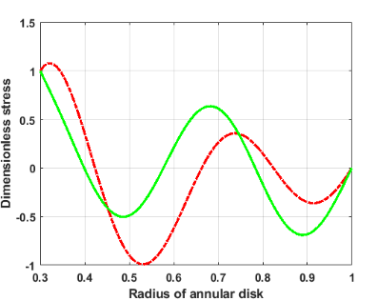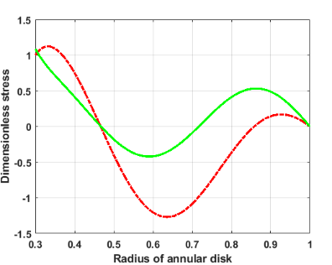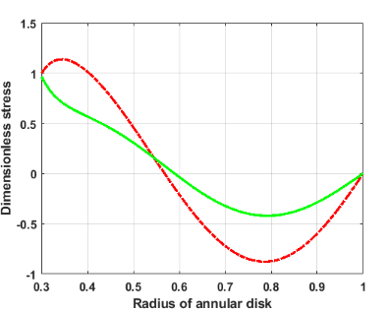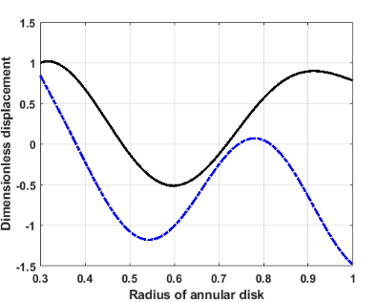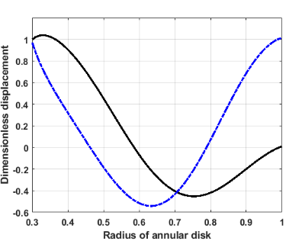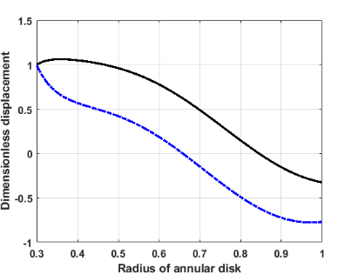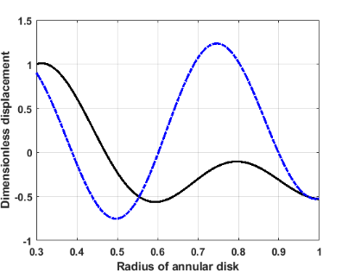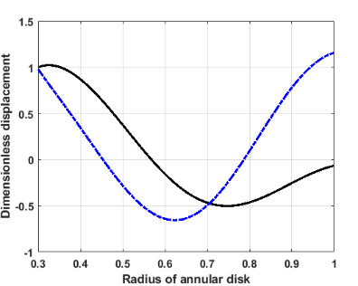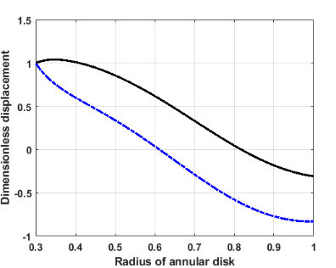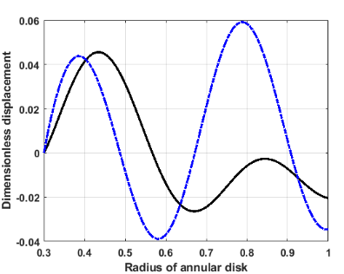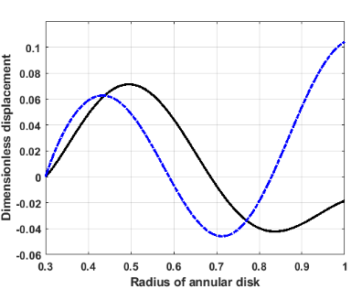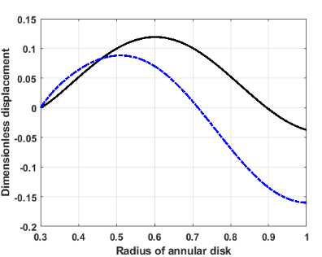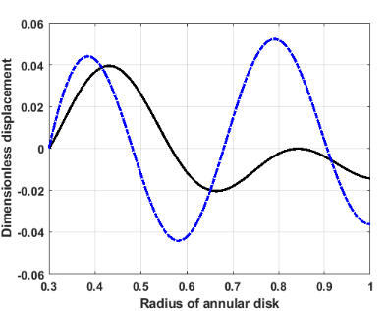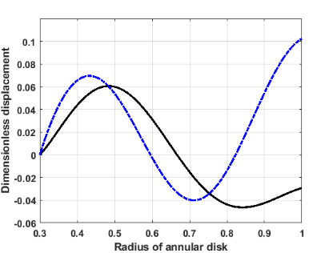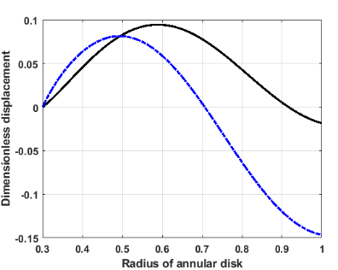

**Free-Free (3,4)**

**Free-Free (2,4)**

**Free-Free (1,4)**

**Free-Free (3,3)**

**Free-Free (2,3)**

**Free-Free (1,3)**

**Fixed-Free (3,4)**

**Fixed-Free (2,4)**

**Fixed-Free (1,3)**

**Fixed-Free (2,3)**

**Fixed-Free (1,4)**

**Fixed-Free (3,3)**

**Free-Free (2,4)**

**Free-Free (3,3)**

**Free-Free (1,4)**

**Free-Free (3,4)**

**Fixed-Free (3,4)**

**Free-Free (2,3)**

**Free-Free (1,3)**

**Fixed-Free (2,4)**

**Fixed-Free (1,4)**

**Fixed-Free (3,3)**

**Fixed-Free (2,3)**

**Fixed-Free (1,3)**

Figure 7. Displacements and stresses distribution of fixed-free and free-free annular rotating disks ()

Figure 6 shows mode shapes of fixed-free and free-free rotating disks with radius ratio 0.3, Poisson’s ratio 0.3 and dimensionless speed 2.0 for and . As illustrated for the mode shapes, each circle inside of the disk demonstrates the number of nodal circles. Displacements (radial and circumferential) and stresses (radial and shear) distribution of a thin rotating annular disk depicted in Figure 7. First six graphs are related to displacements distribution of the rotating disk (black solid line is radial displacement and blue dash line is circumferential displacement) with radius ratio 0.3, Poisson’s ratio 0.3 and dimensionless speed 2.0 for and for fixed-free boundary condition and other six graphs are for free-free boundary condition. Last twelve graphs are related to stresses distribution of the rotating disk (red green line is shear stress and red dash line is radial stress) with the same design parameter as displacement distribution.

**COMPARISON**

In order to validate the presented analytical procedure, the results from this analysis were compared with the established results reported by Lyu et al. [15]. Table 1. shows a comparison of the dimensionless natural frequencies reported in reference [15] and those presented in this study for the free-free rotating disk with radius ratio 0.2 and Poisson’s ratio 0.3 for forward wave in fixed-coordinate. Table 2. shows the comparison of natural frequencies for fixed-free with the conditions as described in table 1.

Table 1. Comparison the natural frequencies (free-free)

|  |  |  |  |  |  |  |
| --- | --- | --- | --- | --- | --- | --- |
| Speed | Dimensionless natural frequency () | | | | | |
|  | **(1,1)[15]** | **(1,1)** | **(1,2)[15]** | **(1,2)** | **(1,3)[15]** | **(1,3)** |
| .0 | 4.027 | 4.027 | 2.518 | 2.518 | 3.563 | 3.564 |
| .2 | 4.145 | 4.145 | 2.925 | 2.925 | 4.164 | 4.165 |
| .4 | 4.294 | 4.294 | 3.304 | 3.304 | 4.752 | 4.753 |
| .6 | 4.480 | 4.480 | 3.650 | 3.651 | 5.317 | 5.318 |
| .8 | 4.705 | 4.705 | 3.964 | 3.965 | 5.855 | 5.857 |
|  | 4.962 | 4.962 | 4.250 | 4.251 | 6.368 | 6.370 |
|  | 5.235 | 5.235 | 4.510 | 4.511 | 6.856 | 6.859 |
|  | 5.485 | 5.485 | 4.748 | 4.749 | 7.325 | 7.328 |

Table 2. Comparison the natural frequencies (fixed-free)

|  |  |  |  |  |  |  |
| --- | --- | --- | --- | --- | --- | --- |
| Speed | Dimensionless natural frequency () | | | | | |
|  | **(1,1)[15]** | **(1,1)** | **(1,2)[15]** | **(1,2)** | **(1,3)[15]** | **(1,3)** |
| .0 | 2.223 | 2.223 | 2.726 | 2.729 | 3.635 | 3.637 |
| .2 | 2.541 | 2.541 | 3.222 | 3.225 | 4.274 | 4.276 |
| .4 | 2.847 | 2.847 | 3.694 | 3.698 | 4.901 | 4.904 |
| .6 | 3.129 | 3.129 | 4.135 | 4.140 | 5.510 | 5.514 |
| .8 | 3.374 | 3.373 | 4.541 | 4.547 | 6.094 | 6.098 |
|  | 3.572 | 3.572 | 4.910 | 4.916 | 6.650 | 6.654 |
|  | 3.723 | 3.723 | 5.243 | 5.249 | 7.180 | 7.182 |
|  | 3.830 | 3.830 | 5.544 | 5.550 | 7.684 | 7.685 |

**Conclusion**

In this research, the main emphasis is to provide the analytical prediction of in-plane natural frequencies and depict their mode shapes, stresses and displacements of a homogeneous, isotropic, and elastic rotating annular disk. Analytical methods have been developed to determine the effects of rotational speed and radius ratio on natural frequency and dynamic elastic stability of the rotating disks were related to the mode of vibration and type of circumferential wave occurring. In the development of an analytical solution, two-dimensional plane stress theory is employed, and the governing equations are solved to obtain the exact frequency equation of annular disks. Considering the disk is rotating at a constant angular speed and conditions of steady-state rotation and no external forces acting on the disk were assumed. The proposed method in this research can be effectively applied to depict natural frequency, critical speed, modal displacements and stresses and deformed shape of rotating disk for various rotational speeds, radius ratios and boundary conditions and the major results are as follows:

* The governing equations of motion are solved to determine modal information such as modal in-plane stresses and displacements, mode shapes and dimensionless natural frequencies for linear in-plane vibration of rotating annular disk.
* The provided method is also capable of computing all dimensionless natural frequencies within a wide range of rotating speeds, radius ratio and Poisson’s ratio.
* It was observed that the effect of rotational speed on natural frequency depended on the radius ratio, the mode of vibration, Poisson’s ratio, stiffness, density of material, and the type of wave occurring.
* The presented results can provide guidelines to assist designers in selecting appropriate geometries and materials to avoid critical speeds for operating speeds.

**REFERENCES**

[1] Love A., “A Treatise on the Mathematical Theory of Elasticity,” Dover Publications, New York, 1944.

[2] Onoe M., “Contour vibrations of isotropic circular plates,” Journal of the Acoustical Society of America, vol. 28, pp. 1158–1162, 1956.

[3] Chen JS, Jhu JL., “On the in-plane vibration and stability of a spinning annular disk,” Journal of Sound and Vibration 195, pp. 585– 593, 1996.

[4] Chen JS, Jhu JL., “In-plane Stress and Displacement Distributions in a Spinning Annular Disk Under Stationary Edge Loads,” Journal of Applied Mechanics 64, pp. 897-904, 1997.

[5] Hamidzadeh HR., “In-plane free vibration and stability of rotating annular discs,” Journal of Multi-body Dynamics 216, pp. 371-380, 2002.

[6] Farag NH, Pan J., “Modal characteristics of in-plane vibration of circular plates clamped at the outer edge,” Journal of the Acoustical Society of America 113, pp.1935–1946, 2003.

[7] Bashmal S, Bhat R, Rakheja S., “In-plane free vibration of circular annular disks,” Journal of Sound and Vibration 322, pp. 216–226, 2009.

[8] Bashmal S, Bhat R, Rakheja S., “In-Plane free Vibration Analysis of an Annular Disk with Point Elastic Support,” Shock and Vibration 18, pp. 627-640, 2012.

[9] Hamidzadeh HR, Sarfaraz E., “Influence of Material Damping on In-Plane Modal Parameters for Rotating Disks,” Proceedings of the ASME International Mechanical Engineering Congress and Exposition, Houston, pp. 89-96, 2012.

[10] Sarfaraz E., Hamidzadeh HR., “The Effect of Material Damping on In-Plane Vibration Characteristics of Rotating Disk,” ASNT 22nd Research Symposium, Memphis, pp. 108-112, 2013.

[11] Hamidzadeh HR, Sarfaraz E., “In-Plane Free Vibration and Stability of High Speed Rotating Annular Disks and Rings,” in: Machado JAT, Baleanu D, Luo ACJ (Eds.), Discontinuity and Complexity in Nonlinear Physical Systems, Nonlinear Systems and Complexity, Springer, Cham, pp. 389-408, 2014.

[12] Hamidzadeh HR, Sarfaraz E., “Influence of embedded material at edges on natural frequencies of rotating annular disk,” IEEE 4th International Conference on Nonlinear Science and Complexity (NSC), Hungary, pp. 167-176, 2012.

[13] Sarfaraz E, Hamidzadeh HR., “Influence of Embedded Material on Natural Frequencies of Double Segment Rotating Disk” Journal of Applied Nonlinear Dynamics 2, pp. 175-192, 2013.

[14] Bagheri E, Jahangiri M., “Analysis of In-Plane Vibration and Critical Speeds of the Functionally Graded Rotating Disks” International Journal of Applied Mechanics 11, 1950020, 2019.

[15] Lyu P, Du J, Wang Y, Liu Z., “Free in-plane vibration analysis of rotating annular panels with elastic boundary restraints,” Journal of Sound and Vibration 439, pp. 434-456, 2019.

[16] Lyu P, Du J, Liu Z., “A Semianalytical Solution for In-Plane Vibration Analysis of Annular Panels with Arbitrary Distribution of Internal Point Constraints,” Mathematical Problems in Engineering, Article ID 7269809, 2020.